GenAI
UNIT 1 Hands-On 1 Observations
Generative Artificial Intelligence & NLP Basics

Part 1: Overview of Hugging Face and the Transformers Library

What is Hugging Face?
Hugging Face is a popular open-source platform that allows researchers and developers to share and access pre-trained artificial intelligence models. It serves as a central hub for modern NLP models, making it possible to experiment with advanced architectures without the need for heavy computational resources or long training times. Models such as GPT-2, BERT, and RoBERTa can be directly downloaded and used for experimentation.

What is the transformers library?
The transformers library provides the necessary tools to interact with models hosted on Hugging Face. It offers simple and unified APIs to load, configure, and run transformer-based models. This library supports multiple deep-learning frameworks, allowing users to work in environments such as PyTorch or TensorFlow without changing their approach.

What is the pipeline() function?
The pipeline() function is a high-level utility that simplifies NLP workflows. It automatically manages:
- Converting raw text into tokens
- Passing tokens through the model
- Translating model outputs into readable results
As a result, complex NLP tasks can be executed with very few lines of code.

Observations
- Hugging Face makes advanced AI models easily accessible.
- The transformers library hides low-level implementation details.
- The pipeline() function is well-suited for rapid experimentation and learning.

Task 1: Seed Value Experiment

Objective
The aim of this task was to study how randomness influences text generation in language models by modifying the seed value and observing the changes in output.

Experiment Configuration
- Model Used: GPT-2
- Input Prompt:
“Generative AI is a revolutionary technology that…”
- Seed Values Tested: 42 and 68

Output (Seed = 42)
Generative AI is a revolutionary technology that enables a wide range of intelligent systems to work independently from one another.

Generated Output (Seed = 68)

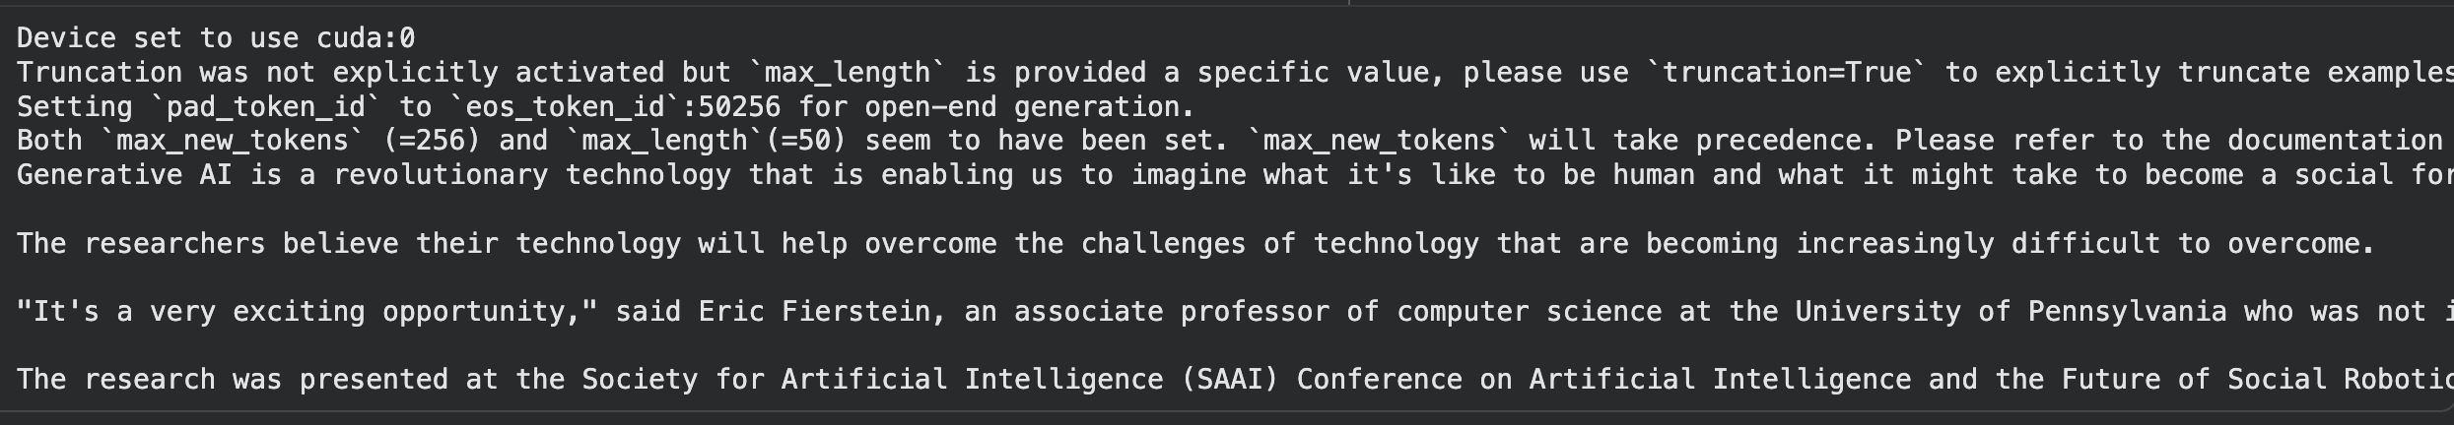
Generative AI is a revolutionary technology that is enabling us to imagine what it's like to be human and what it might take to become a social force," he said. "It's not just that we can be AI, or it could be something else entirely."

The researchers believe their technology will help overcome the challenges of technology that are becoming increasingly difficult to overcome.

"It's a very exciting opportunity," said Eric Fierstein, an associate professor of computer science at the University of Pennsylvania who was not involved in the research. "It's a very exciting time for the field, and a very exciting time for the future of the world."

The research was presented at the Society for Artificial Intelligence (SAAI) Conference on Artificial Intelligence and the Future of Social Robotics, held Nov. 20-22 in Toronto, Canada.

Observations
- Keeping the same seed produces identical output across runs.
- Changing the seed value leads to noticeable variation in generated text.
- Seed 42 results in a more direct and informative response.
- Seed 68 produces a more abstract and reflective continuation.
- This confirms that text generation is probabilistic in nature.

Key Takeaway
Seed values play an important role in controlling randomness during text generation. Even with the same model and prompt, altering the seed can significantly change the output.

Task 2: Comparative Study of BERT, RoBERTa, and BART

Objective
The objective of this task was to compare multiple transformer models across different NLP tasks and understand how architectural design affects their performance.

Models Considered
BERT
- Encoder-only architecture
- Trained using Masked Language Modeling
RoBERTa
- Improved and optimized version of BERT
- Trained with larger datasets
BART
- Encoder-Decoder architecture
- Trained to reconstruct corrupted input sequences

Experimental Results
Task | Model | Classification | What happened? | Why did this happen? (Simple Explanation)
Generation | BERT | Failure | Generated only dots / meaningless output | BERT only understands text; it is not built to generate new text
Generation | RoBERTa | Failure | Repeated or echoed the input | Like BERT, RoBERTa cannot predict the next word
Generation | BART | Failure | Generated incoherent or low-quality text | BART can generate text, but this version is not trained well for free text generation
Fill-Mask | BERT | Success | Predicted create, generate, produce | BERT is trained to guess missing words
Fill-Mask | RoBERTa | Success | Predicted generate, create, discover | RoBERTa is trained even better at guessing missing words
Fill-Mask | BART | Success | Predicted create, help, provide | BART is trained to fix corrupted or missing text
Question Answering | BERT | Partial | Extracted “such as hallucinations” | The model understands the sentence but is not trained to pick exact answers
Question Answering | RoBERTa | Partial | Extracted “, bias, and” | Same problem as BERT — no training for answer selection
Question Answering | BART | Partial | Extracted “and deepfakes.” | BART is not meant for selecting exact answer spans
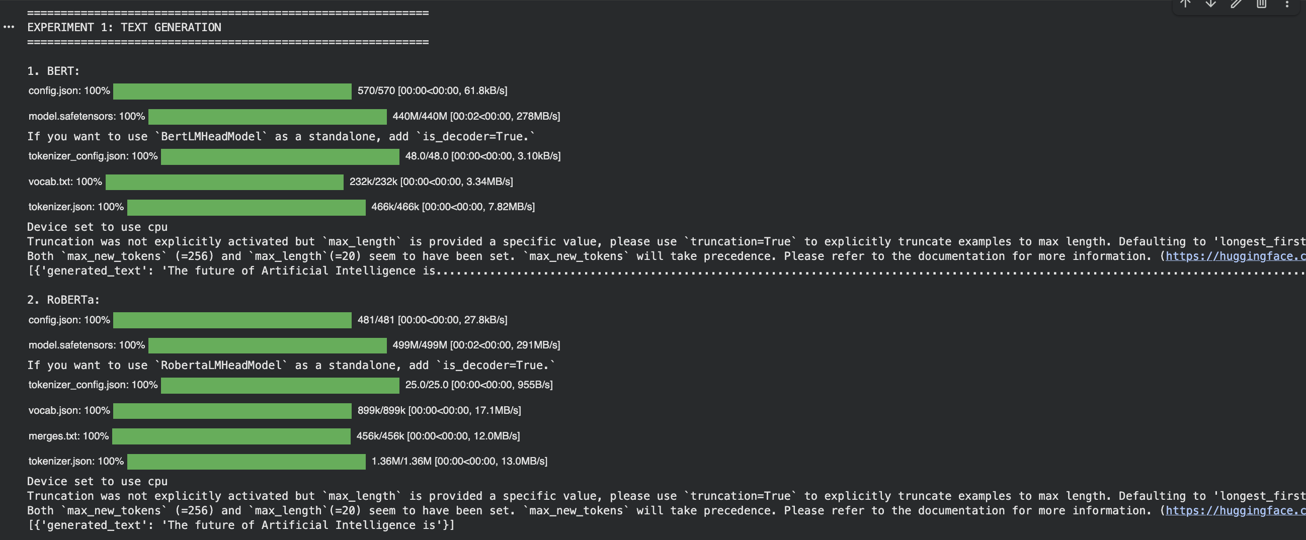
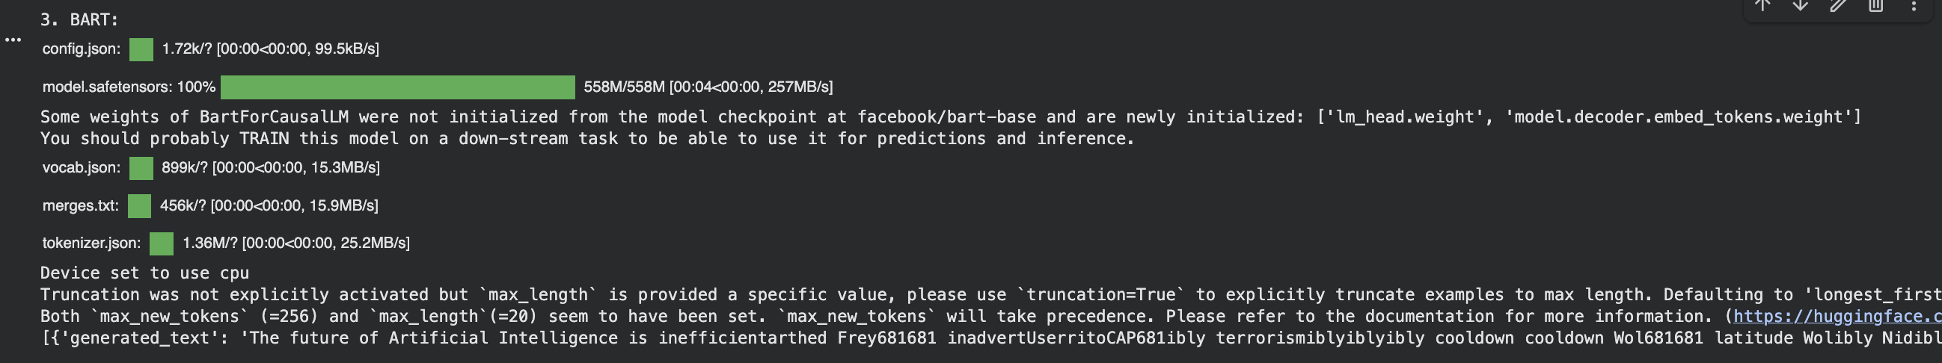
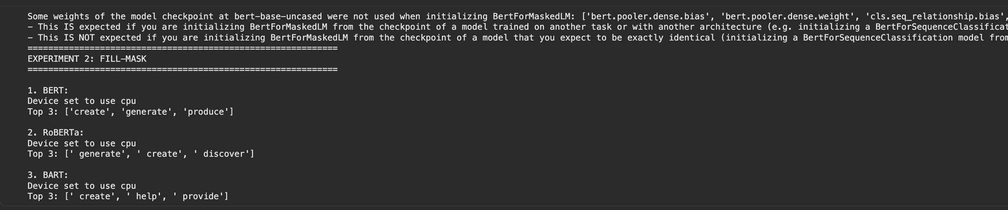
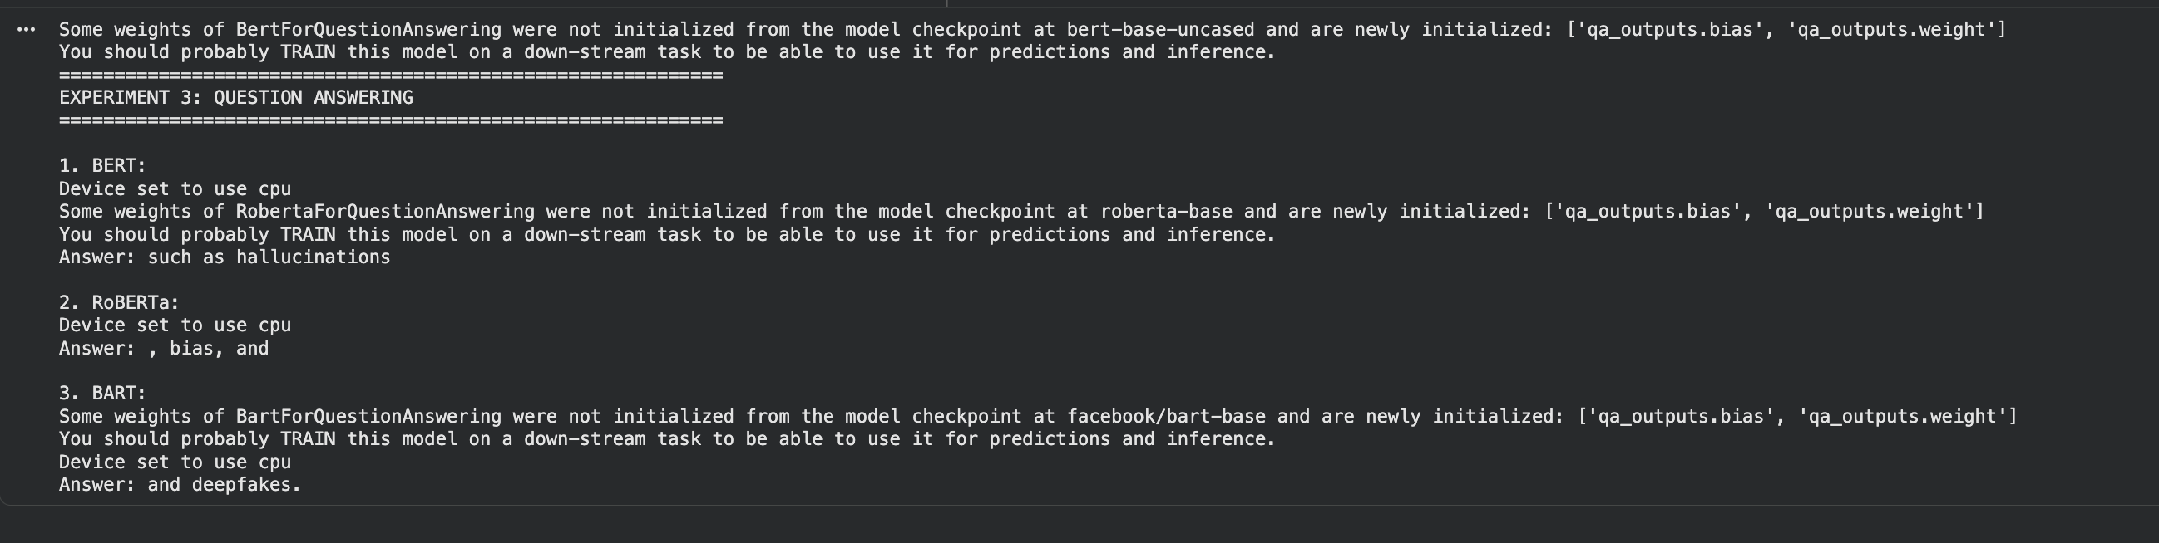

Observations
- Encoder-only models are ineffective for text generation.
- BERT and RoBERTa perform best in masked word prediction.
- BART requires task-specific training to generate meaningful text.
- Question answering tasks need fine-tuned models for accuracy.

Key Takeaway
A model’s architecture and training objective directly determine which tasks it can perform well. Using a model outside its intended purpose results in poor performance.

Task 3: AI-Based Spell Check and Grammar Correction System

Objective
The objective of this task was to implement a practical NLP application that corrects grammatical and spelling errors using contextual understanding rather than rule-based methods.

Project Overview
The spellcheck system identifies incorrect words by masking them and uses BERT to predict suitable replacements based on surrounding context. This approach allows for grammar-aware corrections instead of simple dictionary matching.

Tools and Technologies
- Model Used: bert-base-uncased
- Task Type: Fill-Mask
- Library: Hugging Face Transformers

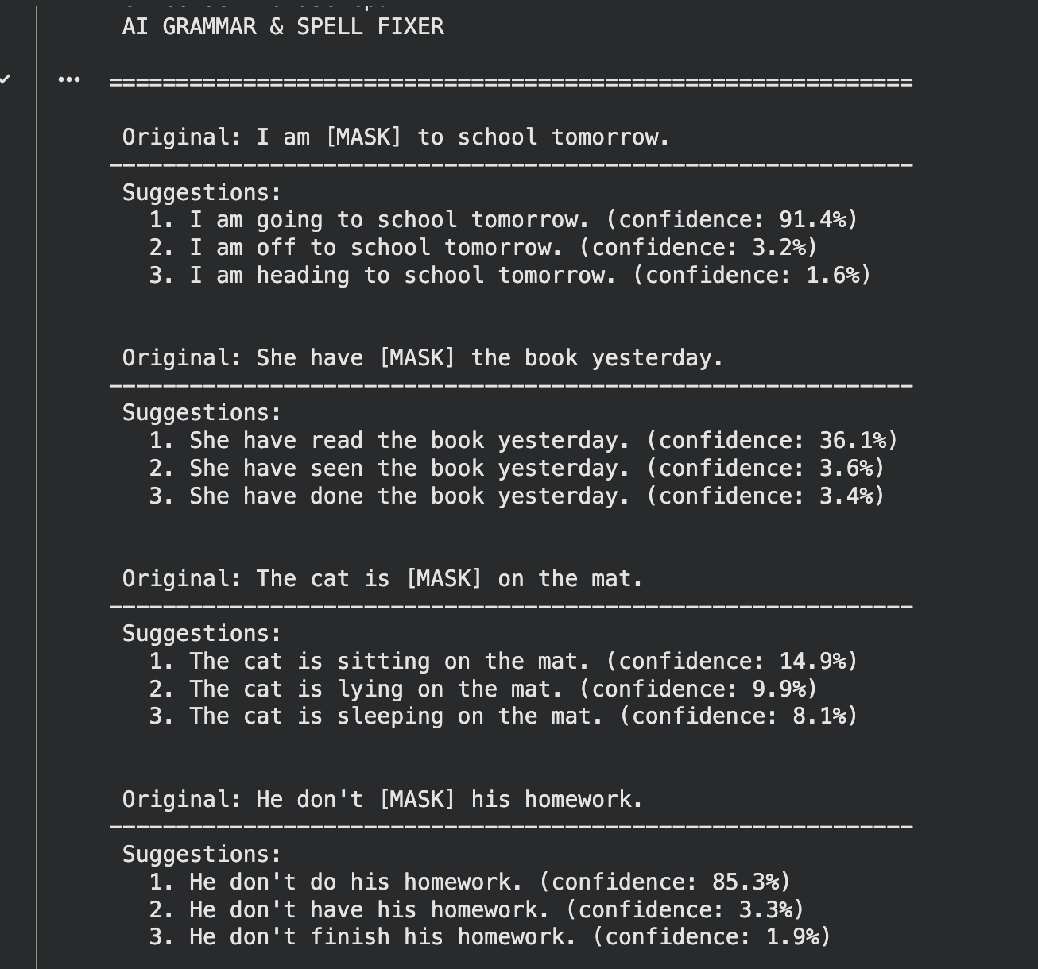
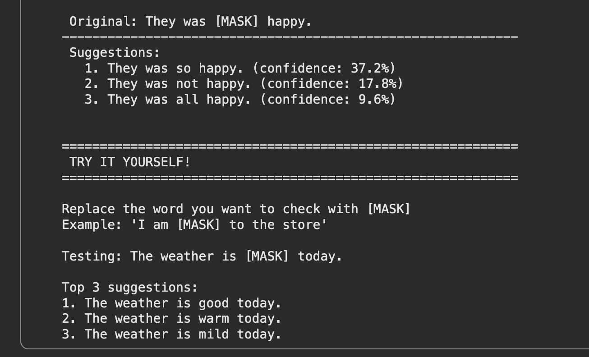

Observations
- BERT produces accurate grammatical corrections when the error is clearly masked.
- High confidence scores indicate strong contextual understanding.
- The system performs well for common grammatical structures.
- Manual identification of incorrect words is required.

Limitations
- Automatic error detection is not supported.
- Only one word can be corrected at a time.
- Performance depends on sentence clarity and context.

Final Key Takeaway
This set of experiments demonstrates a complete learning progression—from understanding randomness in text generation, to evaluating model capabilities, and finally applying this knowledge to build a useful AI-based language tool. Selecting the correct model for a specific task is essential for achieving reliable results in Generative AI applications.

